Salford University Race Team Design Report

Formula Student UK 2016: Class 2

# Executive summary

The SR-01 car is designed first with rule compliance and education in mind as the team are novices in vehicle engineering and the competition. Using commonly sourced components and techniques available the vehicle serves as a test bed and starting point for future teams to build upon.

The major highlight this year is that the vehicle represents our first foray into race car design and the emphasis has been on building team capability first, with the ambition that with a great team, a great car will follow in future years.

# Project Management Methods & Team Communication

Project management, when the team was founded, was built on (FDD) Feature driven design. This is the breakdown of the overall model into features and planning/designing and building by feature to achieve the full model. While it produced results, project managers found it hard to measure what had been achieved and what was left to be done other than in bi-weekly time consuming meetings.

In order to streamline this process we utilized a project management style known as Agile. Agile is a Scrum strategy traditionally used by software engineers used to breakdown features into achievable short term tasks that are to be completed in a series of 2 week sprints. Feature requirements are captured as a list of tasks in a feature backlog. Tasks are worked on and completed during sprints and moved put on hold if unable to be completed until another task has been completed e.g. Design freeze. One of the key features of Agile is that it does not have any engineering style requirements meaning that it suited our preexisting FDD style.

The implementation of Agile could be viewed as more of an extension of FDD; increasing our ability to bring on new team members as it became easier to track the progress of each feature and where their work would be needed where as previously meetings would have been needed to obtain where progress on each development was.

Along with the Agile workflow we moved from a excel Gantt chart to Trello. Trello is an online collaborative task service that uses a collection of lists and cards to organize projects. This allowed for constant access to live updates of feature and sprint status, reducing the time in the meetings allocated to feature progress update and increasing accessibility for cross sub team work with being able to allocate tasks that their skill set suited. We were also able to document successes and failures to a greater extent due to the greater data available of which task was holding back a team or where they had excelled. This allows us to improve the Agile system further by designing more appropriate tasks to be completed within sprints and help shape allocation of tasks to build and push team members skills.

# Starting Points and General Decisions

Upon examination of the class 2 requirements the initial approach is to produce a demonstrably rule compliant early iteration, with the intent that this “blueprint” will form a track ready rule compliant vehicle in 2017.

Along with the design for manufacture goals, the decision was made to attempt the chassis fabrication to demonstrate this capability.

Due to cost and team capability the chassis type chosen is a steel tube space frame design. To select a supplier a request for quotation was sent to a range of local and national suppliers, with Proformance metals’ custom grade of carbon based cold drawn seamless steel tube selected due to its MSA and FIA certification and heavy use in roll cage and chassis applications. The steel was selected for its high strength (0.2% yield of 370Mpa). Gauges of 12swg and 16swg have been used to conform to FS 2016 design rules.

Wheel selection consisted of 2 considerations: Cost & availability, and the use of a 10” wheel in the hope component packaging would be more forgiving vs. the smaller 10” wheels.

After working with the staff at Avon and Hoosier, a Hoosier tire was chosen based on popularity among the other teams and wheel fit, the idea that if this tire satisfies the design intent across a broad range of designs then it will likely satisfy out requirements at this early stage. Until access to the Tire Test Consortium is affordable, this was deemed a sensible approach.

At a system level the overall dimensions of the vehicle are driven by a number of factors, from first principles: The space claim of the driver’s cockpit and leg space, the powertrain footprint, and initial research on the relationship between track and wheel base.

In order to reduce overall size the wheel base chosen was 1600mm this number reflects satisfying the rule compliance >1525mm. Research suggests around a 1.6:1 wheel base to track ratio provides a good compromise between straight and cornering performance, and good handling characteristics.

A track of 1200/1200 (front/rear) has been selected giving a ratio of 1.33:1 (Wheelbase/Track) which should provide better low speed response and cornering ability, at the expense of straight line performance, the intent being that the track layout is more suited to handling than power.

# Chassis Design

The floor of the chassis will be carbon fibre plate to close out the underside of the vehicle, and also include the firewall, the firewall is then covered in a heat shield material sheet.

A simple approach was employed during the initial development stage of designing the chassis which was to design for purpose. This required the initial design of the chassis to be able to fit the specifications of the rules and safety guidelines as well as its ability to contain the driver safely and with relative comfort.

All CAD models of the chassis were designed with the intention of manufacture, this required parts to be considered as weldments as well as consideration into trimming members at the point junction points of the chassis.

Rev 01 had a very simple design which incorporated only the necessary tube members required. The length of Rev 01 chassis is 2020mm, with a front- rear axle difference of 1500mm.

An important influence in the development stage of designing the chassis was to ensure that it was lightweight yet rigid enough to support the resulting forces acting on a formula student car.

Rev 02 was designed with extra tube members in the front bulkhead of the chassis with two parallel beams which run from the front roll hoop to the front of the chassis, these members also make the chassis very stiff in the forward direction.

Rev 03 and the final chassis design contains more structural members than its predecessors. However material and weight has been reduced in several areas such as the tow bar mount is an already existing structural member of the chassis. A key difference between the final chassis is the fact that the base of Rev03 is designed with the aerodynamics package in consideration. The front and rear of the Rev 03 chassis contain bulkheads that are elevated in comparison to the cockpit. The rear axle of the chassis is also raised to give the effect of a diffuser.

The design of Rev 03 attached high importance to a low centre of gravity and a more even weight distribution. This resulted in more structural members on the lower half of the car, as well as a larger front bulkhead of 900mm in order to give a more even front to rear axle weight ratio.

# Bodywork

The bodywork of the car will be manufactured using a thin fibreglass. The cad model of the bodywork is designed to be mounted directly onto the chassis using bolts which will be fastened onto mounting tabs on the chassis. The aerodynamics package of the car was limited to the bodywork and the diffuser shape of the chassis. The nose cone of the bodywork emphasises the diffuser shape of the car by encouraging the air flow under the car. The nose cone of the bodywork is also designed with a gradual curve to avoid flow separation.

# Powertrain

Simplicity and accessibility are the prevailing drivers for the powertrain development for this vehicle, with the research conducted suggesting the Honda CBR600RR is the most common ICE used in the competition.

For the first vehicle much of the powertrain items are intended to be stock Honda CBR600RR parts including the engine air systems (intake and exhaust) with a simple plenum and intake restriction included to assure rule compliance.

As the team does not currently possess the selected ICE, the powertrain subsystem has been a difficult one to develop. Some considerations have been using the stock gear box or removing it and pursuing a direct drive approach for simplicity.

A Drexler differential has been selected as a suitable off the shelf design component for use with the competition.

# Suspension and Steering

The suspension layout chosen is uneven A arms, push rod actuated, Fox float mxr infinitely adjustable air shock axially aligned. The A arms are tubular steel with welded ends housing a staked spherical bearing, this design was chosen after much research on the issues of using threaded rod ends, flat gussets are included to add rigidity and allow for a platform for the push rod mounting point.

The Fox float mxr air shock is adjustable with a simple hand pump to vary spring rate and travel of the suspension linkage.

The layout and shocks were selected for ease of adjustment and simple fabrication while maintaining the required minimum functional travel compliance.

# Control Arms

The control arms are design with a wish bone type shape and are designed to withstand the stresses and strains associated with cornering. The upper control arm is shorter than the lower control arm producing a camber of -3° which assists aggressive cornering by increasing grip. The upper and lower control arms are made from the same steel as the chassis and both have 2 millimetres thick welded thin plates, on the top and bottom, at the upright end to add extra stiffness. The thin plate on the lower control arms provides an extra function as a platform where the pushrods are attached to the control arms. The lower control arms are design with mounting brackets welded on top of the plates and attached to the pushrod using an M10x1.25 bolts and M10 hex nut style 1.

The control arms are attached to the upright and the chassis using press fitted spherical bearings. Spherical bearing are utilized in the design to accommodate misalignments. The spherical bearing are press fitted into the control arms in order to avoid using rod end bearing which are vulnerable to breakages due to the loading of the control arms. This is very critical on the lower control arms because during cornering maximum load is transferred from the upper control arm to the lower arm which is responsible for failure and twisting of lower suspension arm at the joint due to impact loading.

# Upright

The upright is designed to be simple and cost effective so that the manufacturing related complexities are avoided. It is 60 mm thick and is designed with mounting point for the upper and lower arms and the steering arms.

# Steering Rack

The steering rack used is a Quaife QSH4Q central rack of length 560mm, from end to end, with lock to lock turn of 1.7. The steering rack uses a rack and pinion configuration and is mounted on the floor of the chassis of the car. The steering system of the car is designed with 100% Ackerman and the steering rack is offset 192 mm behind the front wheel centre line yielding a steering arm angle of 20.6°.

# Steering Arm

The steering arm is made from the same steel material as the chassis and is 546 mm long. It has 10mm diameter road end bearings which are attached to the upright and to the clevis on the steering rack.

# Electronics and Instrumentation

The car electronics will consist of an existing electronics wiring harness, ECU, and components of a Honda CBR600RR. The existing wiring harness will be altered for the removal of unnecessary components and the addition of others. The choice to use the same ECU and wiring harness for the vehicle as the engine was for the ease of the electronics system design and the integration into the vehicle. The existing wiring harness and components allowed for the measurement of engine speed, coolant temp, and oil pressure and o2 sensor. A form of data acquisition will be incorporated by attaching a data logger and components such as a MAP sensor, wheel speed sensor and engine speed sensor for increased information for the driver’s benefit and after race analyses.

# Testing and Manufacturing

A material sample has been tested to destruction in a tensile testing machine to determine the material properties. The weld testing layout is scheduled to be tested to destructions prior to raising the order for the full length of steel require for chassis fabrication.

A scale model 3D print of the chassis has been produced to explore and illustrate the design along with providing a good reference for manufacturability.

Following satisfactory test performance of the weld testing the full length of steel can be ordered.

# Side

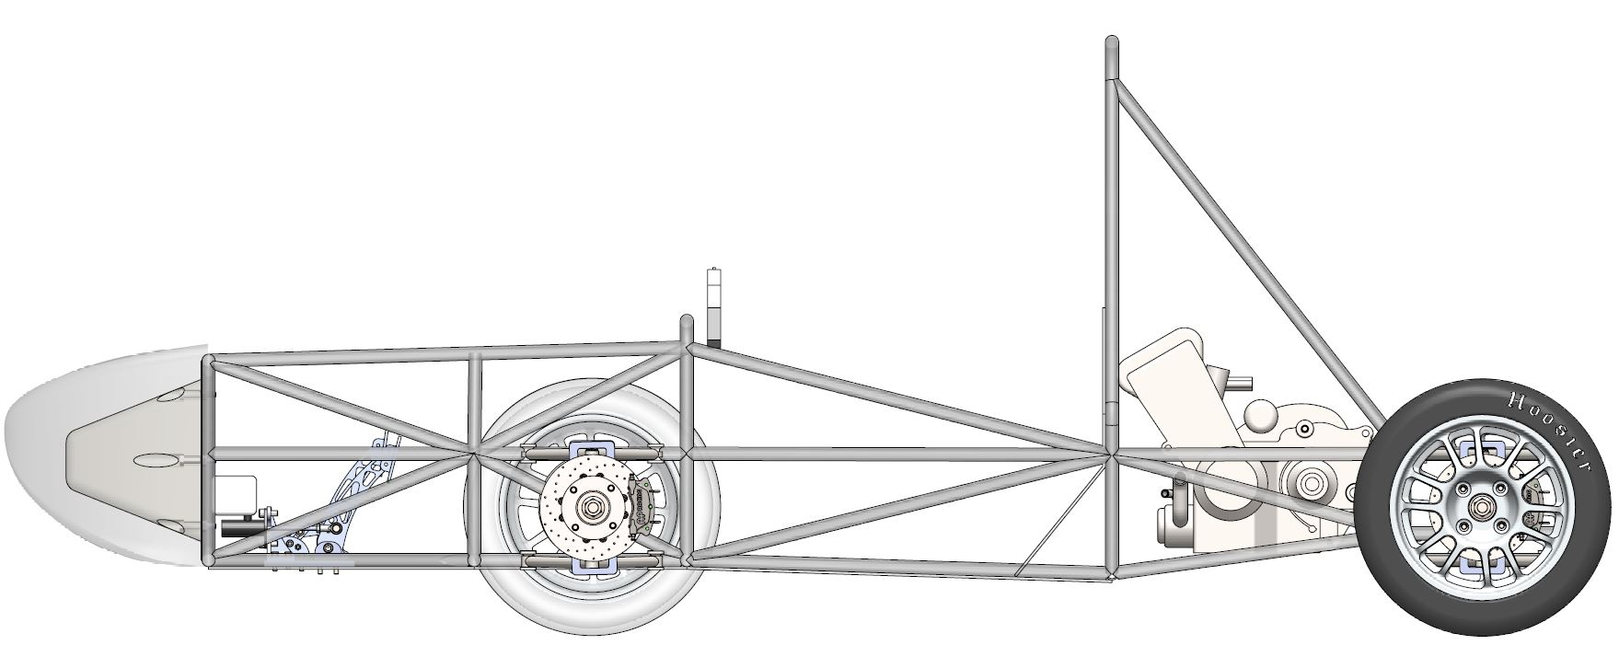

# Top

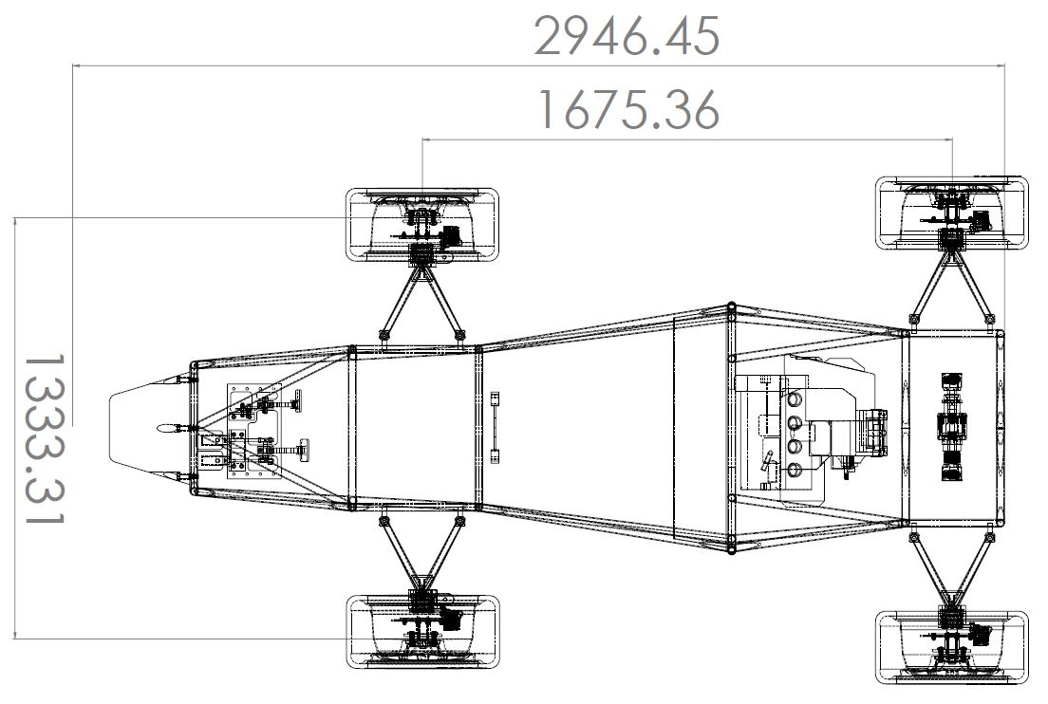

# Front

# 

# Extra Images

